**Cognitive Behavioral Therapy for Anxiety and Related Disorders: A Meta-Analysis of Randomized Placebo-Controlled Trials**

**Abstract**

The purpose of this study was to examine the efficacy of cognitive behavioral therapy (CBT) for anxiety-related disorders based on randomized placebo-controlled trials. We included 41 studies that randomly assigned patients (N = 2,835) with acute stress disorder, generalized anxiety disorder (GAD), obsessive compulsive disorder (OCD), panic disorder (PD), posttraumatic stress disorder (PTSD) or social anxiety disorder (SAD) to CBT or a psychological or pill placebo condition. Findings demonstrated moderate placebo-controlled effects of CBT on target disorder symptoms (Hedges’ g = 0.56), and small to moderate effects on other anxiety symptoms (Hedges’ g = 0.38), depression (Hedges’ g = 0.31) and quality of life (Hedges’ g = 0.30). Response rates in CBT compared to placebo were associated with an odds ratio of 2.97. Effects on the target disorder were significantly stronger for completer samples than intent-to-treat samples, and for individual compared to group CBT in SAD and PTSD studies. Large effect sizes were found for OCD, GAD and acute stress disorder, and small to moderate effect sizes were found for PTSD, SAD and PD. In PTSD studies, dropout rates were greater in CBT (29.0%) compared to placebo (17.2%), but no difference in dropout was found across other disorders. Interventions primarily using exposure strategies had larger effect sizes than those using cognitive or cognitive and behavioral techniques, though this difference did not reach significance. Findings demonstrate that CBT is a moderately efficacious treatment for anxiety disorders when compared to placebo. More effective treatments are especially needed for PTSD, SAD and PD.

**Introduction**

Anxiety disorders are the most prevalent class of mental disorders, with 12-month prevalence rates of 21.3% in the United States (Kessler, Petukhova, Sampson, Zaslavsky, & Wittchen, 2012) and 11.6% worldwide (Baxter, Scott, Vos, & Whiteford, 2013). These disorders are associated with high societal costs (Kessler & Greenberg, 2002; Laynard, Clark, Knapp, & Mayraz, 2007), as well as significant decrements in psychosocial functioning and quality of life (Comer et al., 2011; Hendriks et al., 2016; Olatunji, Cisler, & Tolin, 2007). Fortunately, a sizable body of research has developed over the last several decades demonstrating cognitive behavioral therapy (CBT) to be an effective treatment for anxiety disorders (Hans & Hiller, 2013; Hofmann, Asnaani, Vonk, Sawyer, & Fang, 2012).

CBT refers to a class of scientifically-informed interventions that seek to directly manipulate dysfunctional ways of thinking and patterns of behavior in order to reduce psychological suffering (Hofmann, Asmundson, & Beck, 2013). For anxiety disorders specifically, cognitive models posit that exaggerated appraisal of threat is a core element underlying pathological anxiety (Beck & Haigh, 2014; Clark & Beck, 2010). While differences exist in the content and triggers of anxiety across different disorders, research has increasingly supported the idea that anxiety disorders share core underlying features that make them more similar than different. CBT interventions for anxiety thus share a focus on changing maladaptive beliefs about the likelihood and true cost of anticipated harms by using various cognitive (e.g., cognitive restructuring) and behavioral (e.g., exposure) techniques (Hofmann, 2008; Smits, Julian, Rosenfield, & Powers, 2012).

**Method**

Following the guidelines set forth in the Preferred Reporting Items for Systematic Reviews and Meta-analyses (PRISMA) statement, the protocol for this meta-analysis was registered with the International Prospective Register of Systematic Reviews (PROSPERO) (registration number CRD42016050841).

**Data Extraction**

For each study, the first, second and third authors independently identified the outcome measures to be used for the analysis. This included continuous measures of disorder specific symptoms, other anxiety symptoms, depression, and quality of life, as well as dichotomous outcomes of treatment response and dropout percentage. For those studies that reported multiple indices of treatment response, we selected the most conservative measure. Data was then extracted for the CBT and placebo treatment arms at pre-treatment, post-treatment, and if reported 6-month follow-up (or closest available). If data necessary for calculating effect sizes was not available in the published manuscript, we contacted the authors. We also extracted data on sample and study characteristics, including sample size, demographics, placebo type, CBT treatment type (exposure, cognitive or both; group vs. individual), number of sessions, type of analysis (completer vs. ITT), and year of publication. Data were extracted on two separate occasions by independent raters and compared to ensure accuracy, with discrepancies resolved by the first and second authors.

**Selection of Studies**

To identify eligible studies, we searched PubMed and PsycINFO, for articles published from the first available date to January 4, 2017. The following search terms were used: ((random*)) AND (((cognitive behavior*therap*) OR (cognitive therap*) OR (behavior*therap*))) AND ((GAD) OR (generalized anxiety disorder) OR (OCD) OR (obsessive compulsive disorder) OR (social phobia) OR (social anxiety disorder) OR (specific phobia) OR (simple phobia) OR (PTSD) OR (post-traumatic stress disorder) OR (acute stress disorder))). In addition, we conducted manual searches of reference lists from recently published meta-analyses and review articles. Our search produced 3,215 unique studies, the first 1,165 of which were reviewed for eligibility in Hofmann and Smits (2008) using the same eligibility criteria.

Studies were selected by the first, second and third authors and a team of independent trained assessors. Studies were included in the present meta-analysis if: 1) patients were between ages 18 and 65 and met DSM-III-R, DSM-IV, or DSM-5 diagnostic criteria for acute stress disorder, GAD, OCD, PTSD, SAD or specific phobia as determined by a psychometrically sound and structured diagnostic instrument; 2) patients were randomly assigned to either CBT or placebo (pill or psychological). A psychological placebo was defined as a condition involving interventions to control for nonspecific factors (e.g., contact with a therapist equivalent to the active treatment, reasonable rationale for the intervention, discussion of the psychological problem), and not including any treatment elements with demonstrated efficacy for the condition being treated (e.g. relaxation for OCD or PTSD; Smits & Hofmann, 2009); 3) the clinical severity of the anxiety disorder was assessed by means of psychometrically sound measures; and 4) studies provided sufficient data to calculate effect sizes.

**Risk of Bias Assessment**

We assessed study quality with the Cochrane Collaboration’s tool for assessing risk of bias (Higgins & Altman, 2008). This tool involves assessing each study as containing a high, low or unclear level of bias risk in a number of domains: 1) Sequence Generation: Was allocation of participants to treatment condition adequately generated in a random manner? 2) Allocation Concealment: Was treatment assignment adequately concealed from investigators and participants prior to randomization? 3) Blinding: Were outcome assessors, therapists, and patients (when possible) blind to the treatment patients were receiving? 4) Incomplete Outcome Data: Were outcome data missing at random and imputed using appropriate methods? 5) Selective Outcome Reporting: Were pre-specified outcome variables of interest adequately and completely reported? A total bias assessment was created for each study by assigning a value of 0 (low bias risk), 1 (unclear bias risk), or 2 (high bias risk), and summing the score of each category. The first and second authors independently rated each study and then met to resolve any discrepancies. Inter-rater reliability for the total bias assessment was strong (Cronbach’s α = .81).

**Results**

Study Flow and Characteristics

The flow diagram in Figure 1 shows the number of studies excluded and the reasons for exclusion at each stage of study selection. The final analysis included 41 studies, 16 of which were not included in the Hofmann and Smits (2008) paper. Together these studies short examined a total of 2,835 patients randomized to either CBT or placebo.

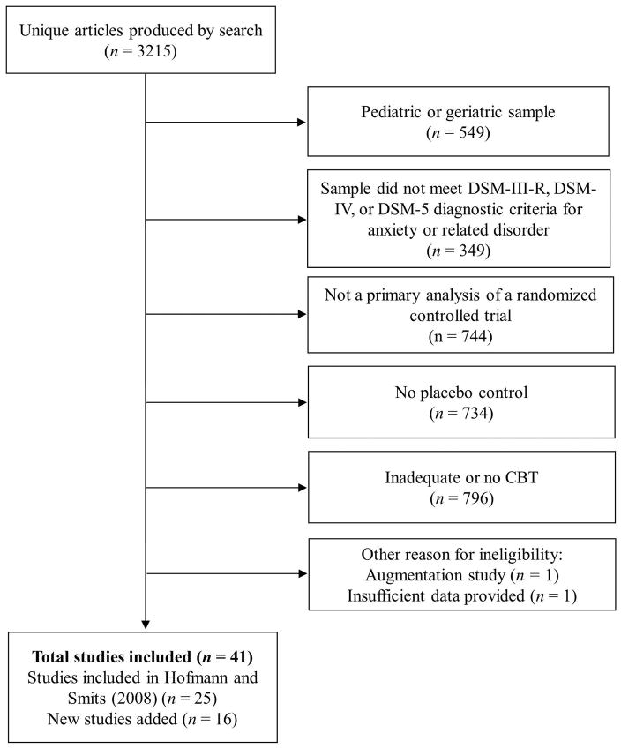

**Refrences**

Bakhshani NM, Lashkaripour K, Sadjadi SA. Effectiveness of short term cognitive behavior therapy in patients with generalized anxiety disorder. Journal of Medical Sciences. 2007;7:1076–1081. [Google Scholar]

Bakker A, van Dyck R, Spinhoven P, van Balkom AJ. Paroxetine, clomipramine, and cognitive therapy in the treatment of panic disorder. The Journal of Clinical Psychiatry. 1999;60:831–838. [PubMed] [Google Scholar]